KME will be selling t-shirts for Pi day and we want YOU to submit a design!
----------------------------------------------------------------------------------------------------
Bring your submission to a KME meeting
Thursday January 25 @ 6:30 // Thursday February 8 @ 6:30
OR
Email us a scanned picture
Email to cmu.kme@gmail.com
----------------------------------------------------------------------------------------------------
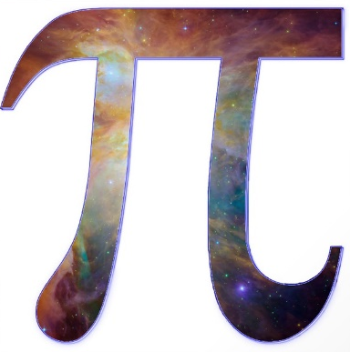
The person with the winning design will receive a FREE T-SHIRT!

